Ideation Phase
Brainstorm & Idea Prioritization Template

Date | 31 January 2025
Team ID
Project Name
Maximum Marks | 4 Marks

Brainstorm & Idea Prioritization Template:
This project brainstorming session focused on identifying key insights that help users understand the global distribution and characteristics of World Heritage Sites. Ideas were evaluated based on business value, user impact, and implementation effort. High-priority features such as country-wise maps, category analysis, top countries, interactive dashboards, and story presentation were selected to ensure maximum user value with efficient development.
Brainstorming Goals
🔹Identify useful insights from the dataset
🔹Decide what visuals/dashboards to create
🔹Improve user understanding of global heritage trends
Step-1: Team Gathering, Collaboration and Select the Problem Statement
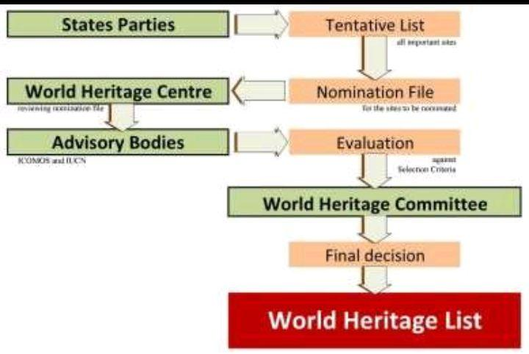
Step-2: Brainstorm, Idea Listing and Grouping
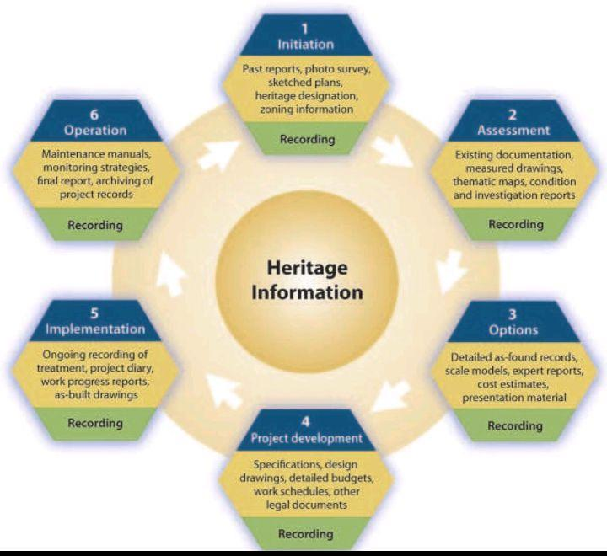
Step-3: Idea Prioritization

